Lab 7
Task 1
CREATE INDEX idx_actual_departure ON flights(actual_departure);
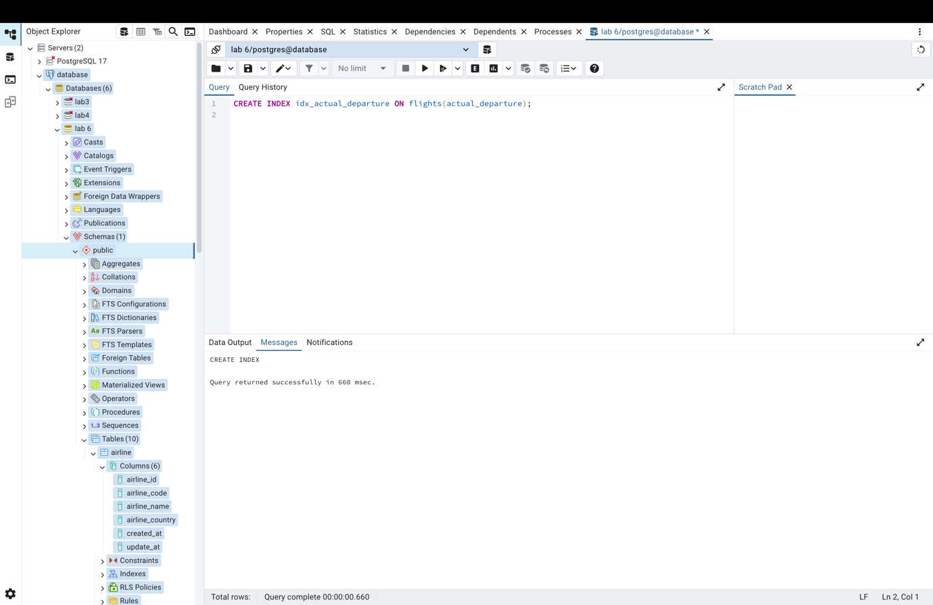
Task 2
CREATE UNIQUE INDEX idx_unique_flight_no_sched_dep
ON flights(flight_no, scheduled_departure);
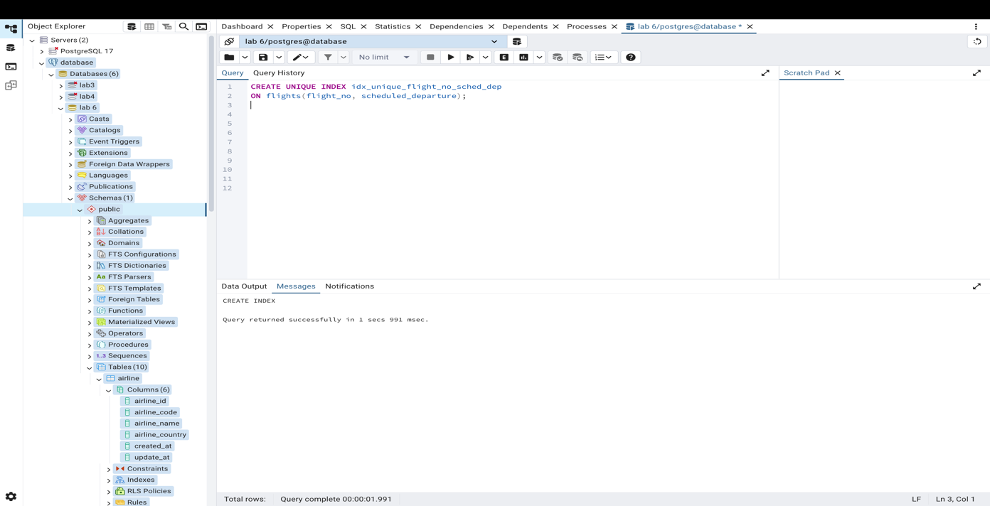
Task 3
CREATE INDEX idx_departure_arrival
ON flights(departure_airport_id, arrival_airport_id);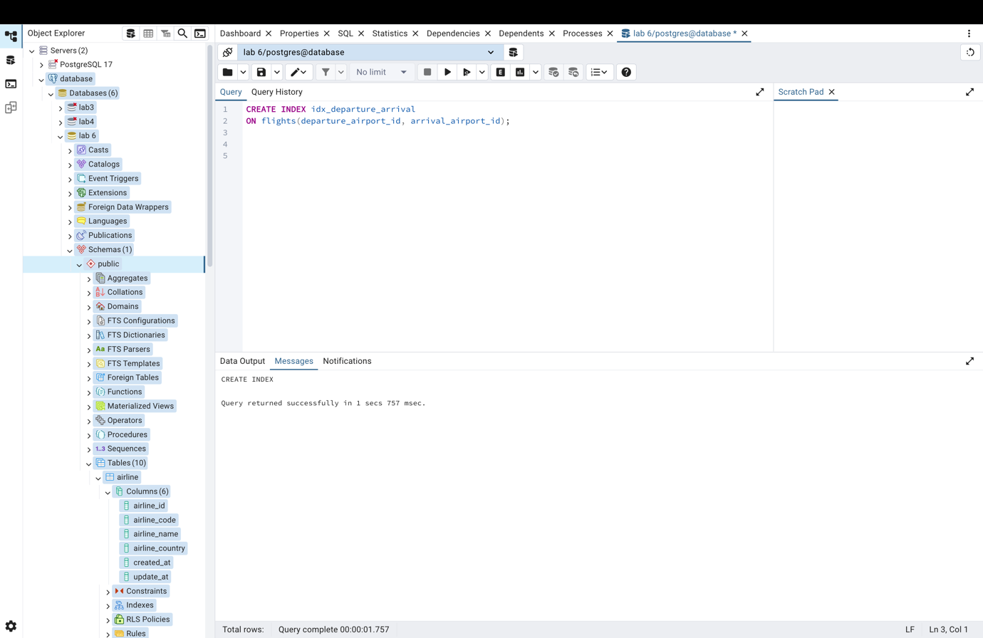
Task 4
SET enable_indexscan = off;

EXPLAIN ANALYZE
SELECT * FROM flights
WHERE departure_airport_id = 1 AND arrival_airport_id = 2;
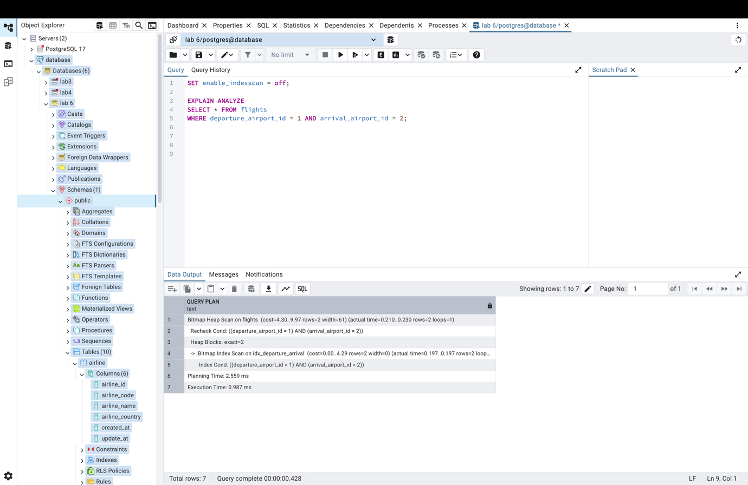
SET enable_indexscan = on;

EXPLAIN ANALYZE
SELECT * FROM flights
WHERE departure_airport_id = 1 AND arrival_airport_id = 2;
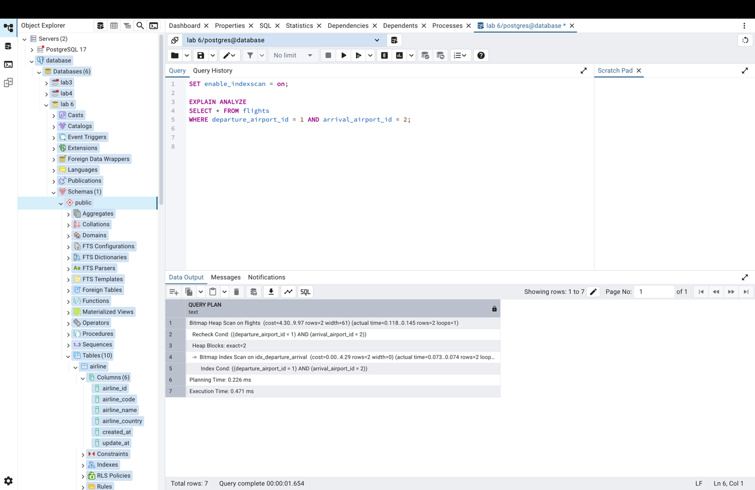
Task 5
EXPLAIN ANALYZE
SELECT * FROM flights
WHERE departure_airport_id = 1 AND a rrival_airport_id = 2;
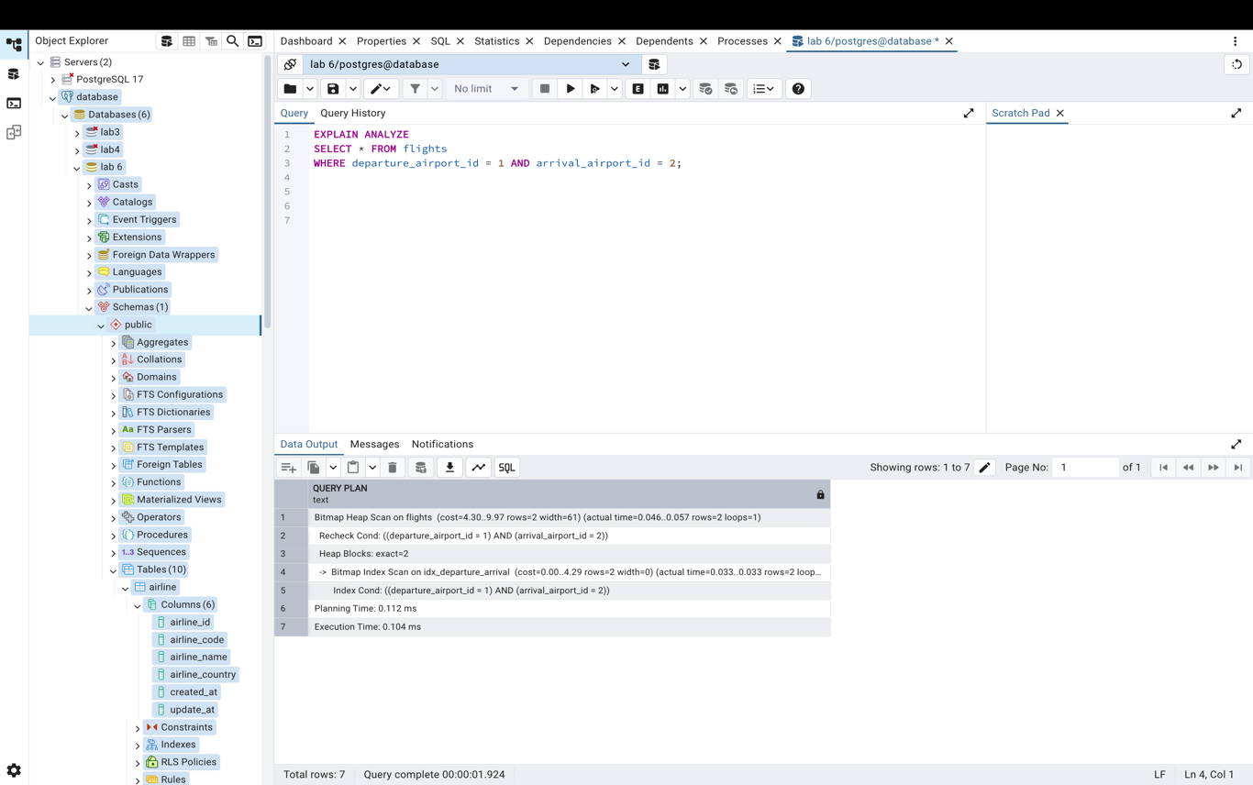

Task 6
CREATE UNIQUE INDEX idx_unique_passport ON passengers(passport_number);

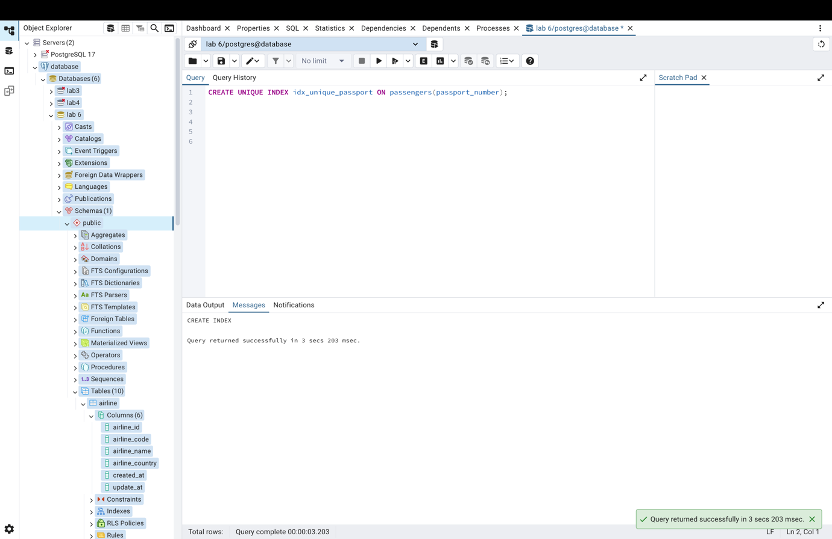

Task 7
CREATE INDEX idx_passenger_info
ON passengers(first_name, last_name, date_of_birth, country_of_citizenship);

EXPLAIN ANALYZE
SELECT *
FROM passengers
WHERE country_of_citizenship = 'Philippines'
AND date_of_birth BETWEEN '1984-01-01' AND '1984-12-31';

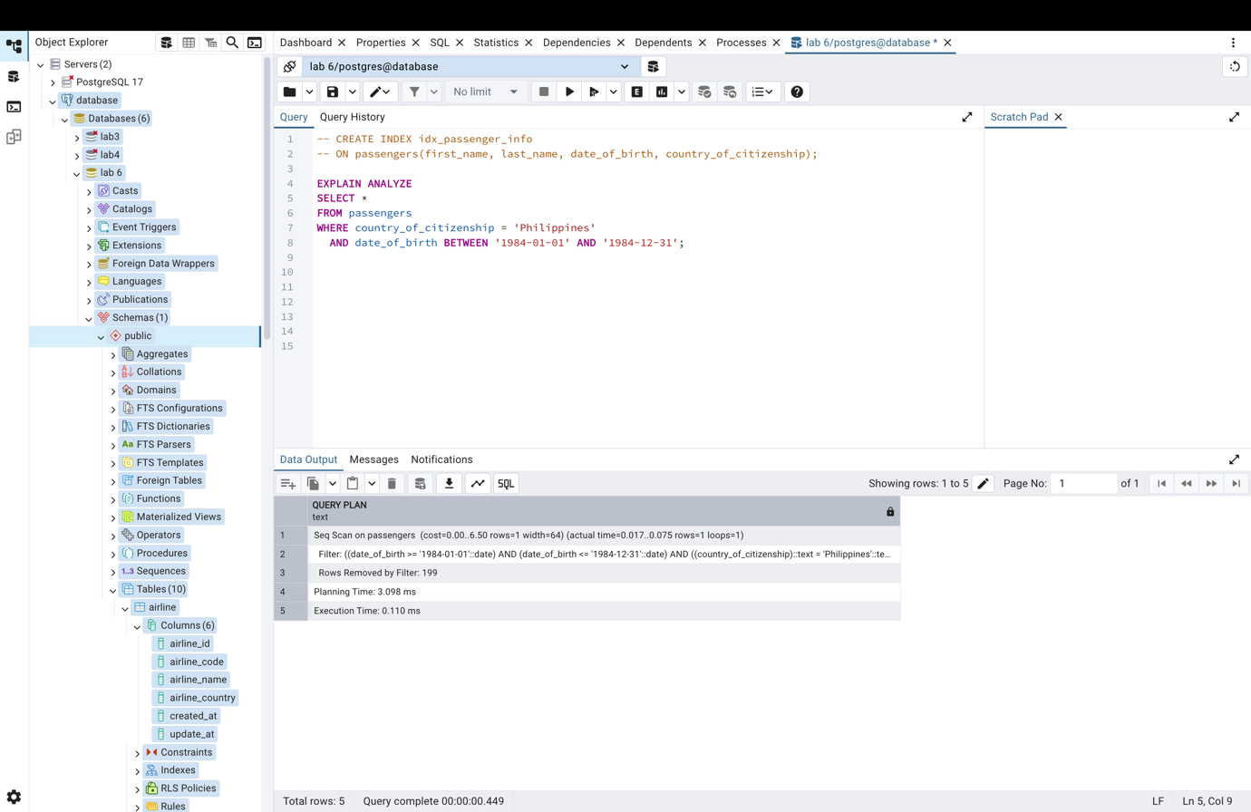

Task 8
SELECT * FROM pg_indexes
WHERE tablename IN ('flights', 'passengers');

DROP INDEX IF EXISTS idx_actual_departure;
DROP INDEX IF EXISTS idx_unique_flight_no_sched_dep;
DROP INDEX IF EXISTS idx_departure_arrival;
DROP INDEX IF EXISTS idx_unique_passport;
DROP INDEX IF EXISTS idx_passenger_info;

